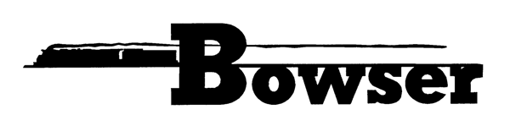
PO Box 322
Montoursville PA 17754
570-368-2379
570-368-5046 Fax
www.bowser-trains.com bowser@bowser-trains.com

New From Bowser – HO 53’ “RAF53C” & “RAF53C” Spine Cars

Trinity “RAF53C” 5 Unit TTAX Spine Car Set
#43692 | Road #555021 | $249.95
#43693 | Road #555044 | $249.95
#43694 | Road #555082 | $249.95
#43695 | Road #555095 | $249.95
#43696 | Road #555110 | $249.95
#43697 | Road #555126 | $249.95
Trinity “RAF33” 3 Unit TTAX Spine Car Set
#43686 | Road #355029 | $149.95
#43687 | Road #355034 | $149.95
#43688 | Road #355078 | $149.95
#43689 | Road #355095 | $149.95
#43690 | Road #355123 | $149.95
#43691 | Road #355140 | $149.95

